DSC-Sponsored Finals Relief Stations:
Overwhelmed by the end-of-semester madness? We’ve got your back (for massages, at least). The DSC is sponsoring Finals Comfort Stations this spring to help you rest, relax, and refresh while studying, writing, and grading.
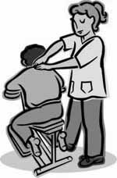
WHO:
All Graduate Center students
WHAT:
Finals Comfort Stations with free 10-minute chair massages, earplugs, and napping stations
WHERE:
Mina Rees Library, First floor beyond the elevators
WHEN:
Tuesday, May 19th, 11am-3pm
Wednesday, May 20th, 11am-3pm

As an extension of the Finals Relief Stations, the Urban Education Student Association is offering:
Tuesday, May 19: FREE YOGA, 12:00 – 1:00 PM in Room 5414

