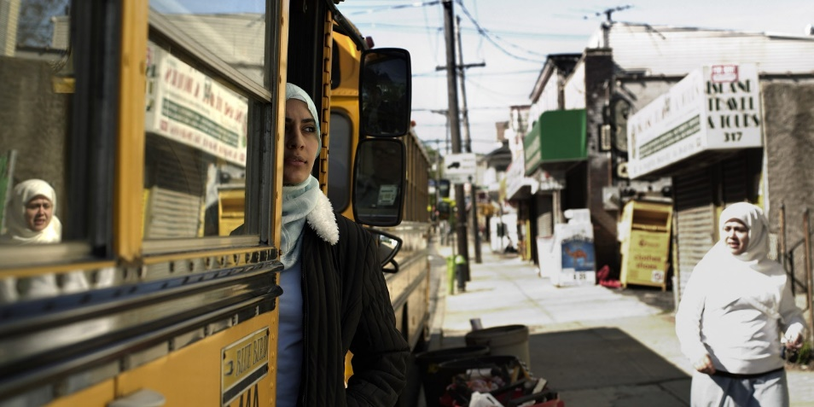

“I Feel Like a Despised Insect”: Coming of Age Under Surveillance in New York

Jeanne Theoharis
February 18, 2016
IN THE SPRING of last year, two New York women were arrested on charges of supporting ISIS, following a joint investigation by the New York Police Department along with federal agencies. According to the U.S. Department of Justice, Queens residents Noelle Velentzas and Asia Siddiqui “plotted to wreak terror by creating explosive devices.” Central to the disruption of this “terror plot,” authorities boasted, was the work of an undercover police detective, although no concrete plan was ever hatched. Indeed, as The Intercept reported, the unsealed criminal complaint reveals the undercover officer’s role in pushing the two women to turn their controversial political sentiments into something more dangerous. In this sense, the arrests were similar to a number of post-9/11 terrorism prosecutions, half of which have involved the use of informants or undercover agents, according to a 2014 report co-authored by Human Rights Watch, which raised concerns over “questionable” and “discriminatory” tactics.
At Brooklyn College, where I teach, news of the arrests prompted a chilling realization among students on campus. Years earlier, this same NYPD officer had come to Brooklyn College, “converted” to Islam, and spent the next four years infiltrating student life. In November, Gothamist broke the story: “Malike Ser” was the cop’s alias; she was known by the nickname “Mel.” There were no links between Mel’s years on campus and the investigation and arrest of Velentzas and Siddiqui (neither of whom went to Brooklyn College or any of the city’s public colleges) — a fact the NYPD has since acknowledged. What remains unclear is what, exactly, Mel was looking for on our campus.
Numerous students and graduates have spoken to me about Mel’s time on campus and the impact it has had on them. They remember seeing her beginning in March 2011 and continuing through into the winter of 2015. She befriended many young Muslim women, among them, those who were particularly political or religious. Students also remember her hovering around those who seemed vulnerable. Mel wormed her way into their friendships, their trips to Coney Island, their picnics and jokes. She even became a bridesmaid in one woman’s wedding. She inquired about their politics and mimicked their religious practices. Claiming she’d been raised in a secular Muslim Turkish family but now wanted to embrace Islam, she recited the Shahada, a declaration of Muslim faith, at the first meeting many students remember her attending, and later spent dozens of hours “praying” next to them. She participated in clubs on campus, joined numerous listservs, and invited students to go with her to events around the city.
Among the young women Mel befriended at Brooklyn College was Fatima (not her real name). A gifted political science student and a politically active, devout Muslim, Fatima came to my office in early 2012 following the Associated Press revelations of widespread NYPD spying on Muslims in New York — a tactic that included placing informants in local Muslim student associations, among them, one at Brooklyn College. The NYPD’s reasoning was partly laid out in its 2007 report titled “Radicalization in the West,” which deemed increased religiosity and political activism among Muslim young people as a dangerous sign of radicalization. The NYPD created a special force — identified by the AP as the “Demographics Unit” — to monitor Muslims for such signs of radicalization. The AP revelations confirmed what many young Muslims believed to be true, and brought to the surface pressures they had long felt. Fatima wanted to study the effects of this climate of fear and suspicion on her generation of Muslim students in New York.
In 2012, Fatima undertook a one-year independent study, writing her thesis around the topic. In the midst of that year, she told me that she suspected someone on campus was an informant. An informant at John Jay College had recently come forward admitting to having spied on fellow Muslim students, sending chills through student groups across the New York metro area. Fatima was right to be concerned, yet I was at a loss for words. I worried about students regarding one another with such suspicions, and it didn’t seem there was anything we could do. I did not ask whom she suspected. It would take 2 1/2 years to confirm Fatima’s suspicions of Mel. In a chilling irony, as Fatima worked on her thesis critiquing surveillance, Mel was surveilling her and her friends.
IN THE 14 YEARS since 9/11 — and particularly since 2008 when I began writing and speaking out about the civil rights violations occurring in a number of federal terrorism prosecutions (including the case of my former student, Syed Fahad Hashmi) — many Muslim students have come to my office in fear and in tears. They describe feeling constantly suspected by many Americans and by law enforcement. Their sense of security — to feel safe on campus or in their mosque, to build community, and to engage in politics — has been compromised. Islam is a welcoming religion, but now, they tell me, they have to view new community members with suspicion. Particularly the more politically engaged students have found themselves holding back in discussions, sometimes in class and especially outside of class. They worry that things they said could be taken out of context and that criticizing the treatment of Muslims in U.S. society could be grounds for more surveillance. After the AP’s investigation, signs went up in the offices of Muslim student groups across the city exhorting members not to discuss any politics whatsoever in these spaces. Many students stopped being active in the Muslim Student Association network out of fear of informants.
In her thesis, Fatima described how such surveillance changes you. Using Foucault’s theory of the panopticon (where social discipline is so pervasive that one internalizes it) and interviews with dozens of Muslim students throughout New York City, she wrote about the ways such state surveillance produces self-surveillance. She revealed how coming of age in the aftermath of 9/11, Muslim American students have grown up in the glare of suspicion and thus constantly feel they have to watch themselves. They watch how they talk in class, socialize, engage in political activities, participate — or don’t — in their mosque and MSA. And perhaps most significantly, surveillance has altered what young people allow themselves to think about or imagine for themselves.
In the months since the discovery of Mel’s time on campus, students and former students describe feeling even more vulnerable. They report repeated panic attacks, pervasive apprehension, and trouble concentrating. “If you let it, it’s enough to make you feel like you are losing your mind,” one former student observed. “There is no one who will call out the predatory targeting of you and your peers because as soon as you say the word ‘terrorist,’ the conversation is over.” Some feel guilty for not confronting Mel years earlier. And after the initial shock, a blanket of sadness has set in; the relentlessness of surveillance, as Fatima put it, means “you will never belong, my children will never belong.”
Students report carrying mental rolodexes, worrying about which friends, loved ones, or romantic interests might be an informant or a cop. “I created an ever-growing list of possible spies, which included everyone from classmates, professors, neighbors, friends, and even family members,” another former student wrote to me, describing her constant anxiety that it was only a “matter of days” before she too might be imprisoned on false terror charges. “The revelation of ‘Mel,’” another explained, “makes it difficult for me to trust anyone. … How can I meet new people, grow within my community and career, when the only thing I can think about is, Could someone within my close circle of trust be an informant?”
The NYPD refused to comment for Gothamist’s first piece; following the attention the article received, however, the department confirmed it had sent an undercover officer to Brooklyn College but denied charges of blanket surveillance. As Gothamist reported in its follow-up article, the NYPD claimed the “investigation” began in the spring of 2011, lasted “for most of a year,” and was closed in early 2012. No arrests were ever made. But, according to Gothamist, interviews with Brooklyn College students resoundingly contradicted the NYPD’s story, as Mel had continued cultivating friendships, attending events, and being present at meetings on campus throughout 2014. Notably, when students of color sought to form a unity coalition to bring together members from a variety of groups on campus (including black, Hispanic, and Muslim groups, as well as Students for Justice in Palestine), Mel attended their fledgling meetings in the spring and fall of 2014. Indeed, Fatima confided her suspicions to me well into the fall of 2012, long past the point when the NYPD claims to have closed its investigation.
ON JANUARY 7, 2016, just days after Gothamist published a story contrasting the NYPD’s claims with the experiences of Brooklyn College students, a historic settlement was announced in two cases against the police department: Handschu v. Special Services Division and Raza v. City of New York. The resolution of the lawsuits, which had been filed in the wake of the AP revelations, was conditioned on a number of terms, including the appointment of a civilian lawyer with national security clearance to monitor the NYPD’s counterterrorism unit; the removal of the 2007 “Radicalization” report from the NYPD website; and the requirement that investigations not exceed three years and be based upon an “allegation or information that is articulable and factual” (although “such allegation or information need not have been verified as true or accurate”).
The settlement is an important development, but there is a danger in seeing the problem as resolved. While much of the coverage of widespread NYPD surveillance portrays it as occurring until the AP’s discovery in late 2011, Mel’s four years on campus largely took place in the wake of those revelations. In the settlement, the NYPD admitted no wrongdoing. In fact, speaking to reporters last month, Police Commissioner William Bratton took pains to reassure the public that the lawyer who will oversee the department’s counterterrorism activities “is not a monitor” and will work on a committee “controlled by the police department.” Nothing in the settlement would necessarily prevent what Mel did at Brooklyn College or give students a way to hold the NYPD accountable for abusing their rights or misleading the public about the extent of her activities on campus. Lengthy undercover “investigations” remain institutionalized through the agreement. While race, religion, or ethnicity cannot drive an official investigation, ideology still can — as it has over the past 15 years. Muslim students who become more religious or more political (who hold “Salafi” or “pro-Palestinian” or “radical” views) will likely remain potent targets for covert investigations.
As tempting as it is to focus on Mel herself, these tactics are not renegade actions. They are consistent with the NYPD’s and the FBI’s approach to Muslim communities after 9/11. They reveal how an “investigation” becomes a perch from which to spy on a community for years, how politically active and religiously conservative students become targets, and how efforts to form coalitions between students of color become suspect. Such political targeting has a long history —from attempts to root out “communists” on campus in the 1950s to the surveillance and disruption of Black Power and antiwar organizing on campus in the 1960s and 1970s (including the use of informants to sow distrust within those groups). Each time, we have come to see such tactics as excessive and degrading of civil rights. Yet here we are again.
Today, a deeper accountability is required. This kind of policing toward Muslim Americans exists because the public has countenanced it. Our tax dollars fund it. In many ways, Americans have acquiesced to the idea that “our safety” requires vigilance, which means more monitoring, more investigations, more preemptive prosecution. While many people have decried the indiscriminate surveillance of Muslim communities, there remains a widespread willingness to see certain kinds of ideas as dangerous. Armed with our fears, we allow this aggressive law enforcement, rarely having to look the consequences or these young people in the eye when we do.
For those coming of age under the glare of constant surveillance, the consequences are deeply destructive. “I desperately want to feel that I belong in this society and place that I call ‘home,’” a former student wrote to me, “but instead I feel like a despised insect, an intruder in someone else’s home.” Similar to the fundamental questions the young people of Black Lives Matter have raised before the nation, these young women wonder whose safety and security counts in American society. As Fatima wrote to me after finding out Mel’s true identity: “Whose safety is actually being prioritized when the invasive nature of the NYPD’s surveillance apparatus is criminalizing an entire faith-based community?”

