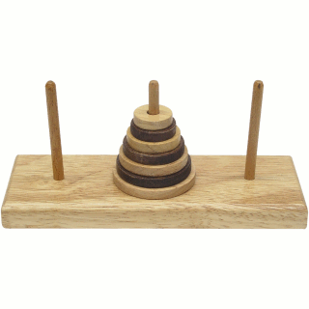
Name of Group members: Date:
Your Name:
2.
3.
4.
Directions to play “Tower of Hanoi”:
Two Rules:
Rule 1 ________________________________________________________________

Rule 2 ________________________________________________________________
Guess: What is the minimum number of moves to solve with 6 rings?
Guess:
Hand this paper in with the following information:
- Find a formula that describes the pattern of solving the puzzle…
Mathematical Formula for the minimum number of moves:
__________________________________________________________________
# of Rings | Minimum # of Moves
1
2
3
4
5
6
- Graph, up to the first 4 points…………x-axis is # of rings…….y-axis is # of minimum moves……… GRAPH

- What is the method that a computer would use in order to place the first ring when solving the puzzle?
Strategy: ________________________________________________________
__________________________________________________________________
__________________________________________________________________
__________________________________________________________________
__________________________________________________________________
__________________________________________________________________
__________________________________________________________________
__________________________________________________________________

Reflection: ________________________________________________________
__________________________________________________________________
__________________________________________________________________
__________________________________________________________________
__________________________________________________________________
__________________________________________________________________
__________________________________________________________________
__________________________________________________________________
__________________________________________________________________
__________________________________________________________________
__________________________________________________________________

