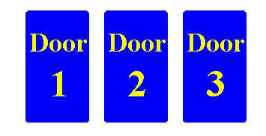
Stick or Switch
Date:
Name:
Monty’s Dilemma
- Write a few sentences explaining whether you would “stay” with your original door choice or “switch” to a new door after seeing one of the choices. Explain why you would “stay” or “switch”.

- Keep a tallied list of your experiment for “staying”. Copy the class list of experimental outcomes for “staying”. Write the experimental probability of “staying”. Explain how we determined this probability.

- Write the experimental probability of “switching”. Explain how we determined the experimental probability.

- Write a few sentences comparing your original prediction in #1 to how you feel now. Would you “stay” or “switch”? Explain why. Use the experimental and theoretical probabilities we obtained during this lesson in your response.

