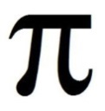
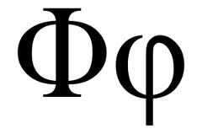
$$\sqrt[12]{2}$$
Another Irrational Number
Task: Using a graphing calculator, see the representation of another irrational number through the lens of music.
BBK: "Give me an A" = 440hz
Some basics: Music is made up of sound. Sound is made from repeating sound waves. The musical pitch of each note has a corresponding frequency measured physically in hz (hertz) or cycles per second. There are some important mathematical relationships between the notes played in music and the frequency of those notes.
There are two constant values in music. The first is that the A note that is 9 white keys below middle C has a frequency of 440 hz. The second constant value in music is the 12th root of 2 (1.0594630943593...) which is the ratio of the frequencies between half tones. So, the frequency of A# is 440 × 1.059... = 466.16376... The frequency of B is 466.1637 × 1.0594 = 493.8833. After you do this _______ times you end up with A an octave higher which equals 880hz. Doubling the frequency creates a note an octave higher. Reversely, dividing the frequency in half creates a note an octave lower.
Pythagoras
The first person to make the connection between math and music was Pythagoras of Samos, a famous philosopher and cult leader who lived most of the time in southern Italy in 5th century BC. Among his claims to fame is the oldest known proof of what we call the "Pythagorean Theorem". If you have never heard of this guy, he is one of western civilizations strangest, but most influential thinkers. For Pythagoras, ratios were everything. He believed every value could be expressed as a fraction (he was wrong, but that is a whole different story). He also is the first to believe in the idea that mathematics is everywhere.

