Name____________________________________________________ Date________________
Partner #1_________________________________________________ Corp-metry, Day 1
Partner #2_________________________________________________
- Your body's surface area is a measurement of the skin that covers your body. Guess _____
Calculation #1: Area of palm _____________ ________________ ______________
X _________
Body surface area _____________ ________________ ______________

The palm of your hand is about one percent of your body's surface area. Doctors sometimes use this piece of information to estimate the percent of the body that is affected in burn victims.
TASK#1: Use your data to approximate the amount of skin on your body.

Calculation #2: height _____________ ________________ ______________
Arm span _____________ ________________ ______________
Area of ‘your square’ _____________ ________________ ______________
X _________
body surface area_____________ ________________ ______________
The picture below is based on a famous drawing by Leonardo da Vinci. As shown in the picture, the person more or less fits in the square.
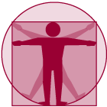
A person's height is approximately equal to his or her arm span (from fingertip to fingertip).
TASK #2:
a. | Measure your height and arm span in centimeters and find the area of "your square."
b. | Many have suggested that three-fifths of the square is a reasonable approximation for surface area.

Calculation #3: height _____________ ________________ ______________
Thigh circumference _____________ ________________ ______________
‘Formula’ body surface area _____________ ________________ ______________
Another way to approximate a person's surface area is to use a simple formula:
Height (cm) • Thigh Circumference (cm) • 2 = Body Surface Area (cm²)
TASK #3: Find your surface area using this formula.

Calculation #4: ‘Nomograph’ _____________ ________________ ______________
Since surface area is also related to weight, health care workers usually use a chart called a nomograph to estimate a person's surface area. To use the nomograph, a person's height (in centimeters) is located in the left-hand column, and a person's weight (in kilograms) is located in the right-hand column. These points are connected with a straight line. The surface area of a person's body is shown where the line crosses the middle scale.
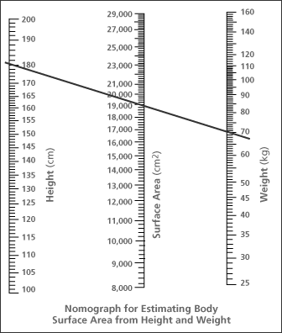

TASK #4: Plot your height and weight. Draw a line to connect these points. Use the nomograph to estimate your own body’s surface area.

_________LT: I can analyze my body geometrically. Corp-metry, Day 1
Name: ____________________________________________ HW#

_________LT: I turn in work on time.

Name | Calculation #1  Handprint | Calculation #2  Your square | Calculation #3  Formula | Calculation #4 Nomograph | Average
***********Hand in your “handprint” from Calculation #1/Task #1**************

_____LT: I can express deep conceptual understanding of mathematical concepts through writing.
Question: Which method do you think best approximates your body surface area? Why?

Rubric:
Task | Possible Points |  |  | Points Earned
Completion of Data | 12
Accuracy | 8
Group behavior | 5
Question | 5
Total | 30

