Name________________________________________________Date__________________________ Week 4

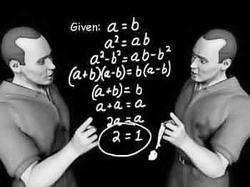
What is occurring between each step on BOTH sides?
What do you notice? Why do you think this is happening?
___________________________________________________________________________________________________________________________
____________________________________________________________________________________________________________________________
____________________________________________________________________________________________________________________________
____________________________________________________________________________________________________________________________
____________________________________________________________________________________________________________________________
____________________________________________________________________________________________________________________________

1._________________________________________________
2._________________________________________________
3._________________________________________________
4._________________________________________________
5. ________________________________________________
6._____________________________________ ____________
7.___________________________________ ______________

