Barbie was invented in 1959 by Ruth Handler, after she saw her daughter and her friends playing with paper dolls. Ruth thought that little girls should have 3-D dolls with removable clothes. Barbie was named after Ruth's daughter Barbara. The original Barbie cost $3.00!

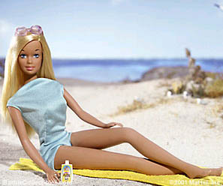 | Barbie doll measurements (mm):  Height: 300  Bust: 150  Waist: 95  Hips: 130  Wrist: 20  Nape to waist: 65  Inside leg: 140

McCall's pattern (cm) | Size 4 | Size 6 | Size 8 | Size 10 | Size 12
Bust  Waist  Hip  Nape to waist | 74.93  55.88  80.01  38.74 | 77.47  58.42  82.55  39.37 | 80.01  60.96  85.09  40.01 | 82.55  63.50  87.63  40.64 | 86.36  67.31  91.44  41.28

Investigating Questions
- The average height of a woman in the United States is 166.624 centimeters. Assume Barbie is of average height and compute her proportional measurements. Refer to the size measurements found on a pattern above. What size outfit should Barbie buy?
- Some people are short-waisted or long-waisted. Measure your height and your nape to waist measurement. Find the ratio of nape and height for you and for Barbie. Are you or Barbie longer in the waist?
- Bodies come in large, medium, and small frames. One way to measure this is around the non-dominant wrist. Measure around your non-dominant wrist. Find Barbie's wrist measurement in centimeters. Compare body frames.
- What is Barbie's ratio of height to waist measurement? What is the ratio of your height to waist measurement? What can you conclude about the proportions for Barbie compared to real human beings?
- Some people are long-legged, some are short-legged. Measure your inside leg length from crotch to floor (no shoes) and compare to Barbie's proportional inside leg length. What can you conclude about Barbie's leg length compared to real human beings?

