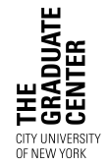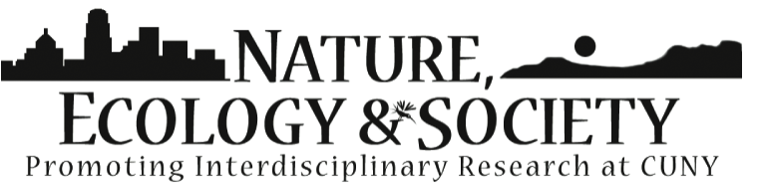

**Sponsors:**



Students in the Ph.D. Subprograms of Environmental Psychology and Social-Personality Psychology, CUNY Graduate Center

Center for Human Environments, CUNY Graduate Center

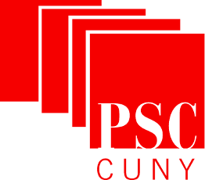

Please Visit **OPENCUNY.ORG/NATURE**

for more information

**Informal discussions and networking over FREE lunch**

**Friday**

**March 14, 2014**

**9:00am to 4:00pm**

**Martin E. Segal Theater**

**The Graduate Center, CUNY**

**365 Fifth Avenue**

**At 34th Street**

**New York City**

**FREE and**

**Open to the Public**

**PRESENTATIONS & ROUNDTABLE DISCUSSIONS!**

* TRANSITIONS FOR WHOM? FOR WHAT?
* CHANGES ACROSS SPACE AND TIME
* POLITICS OF TRANSITION

13th Annual Colloquium

**Our Environment**

**in Transition**