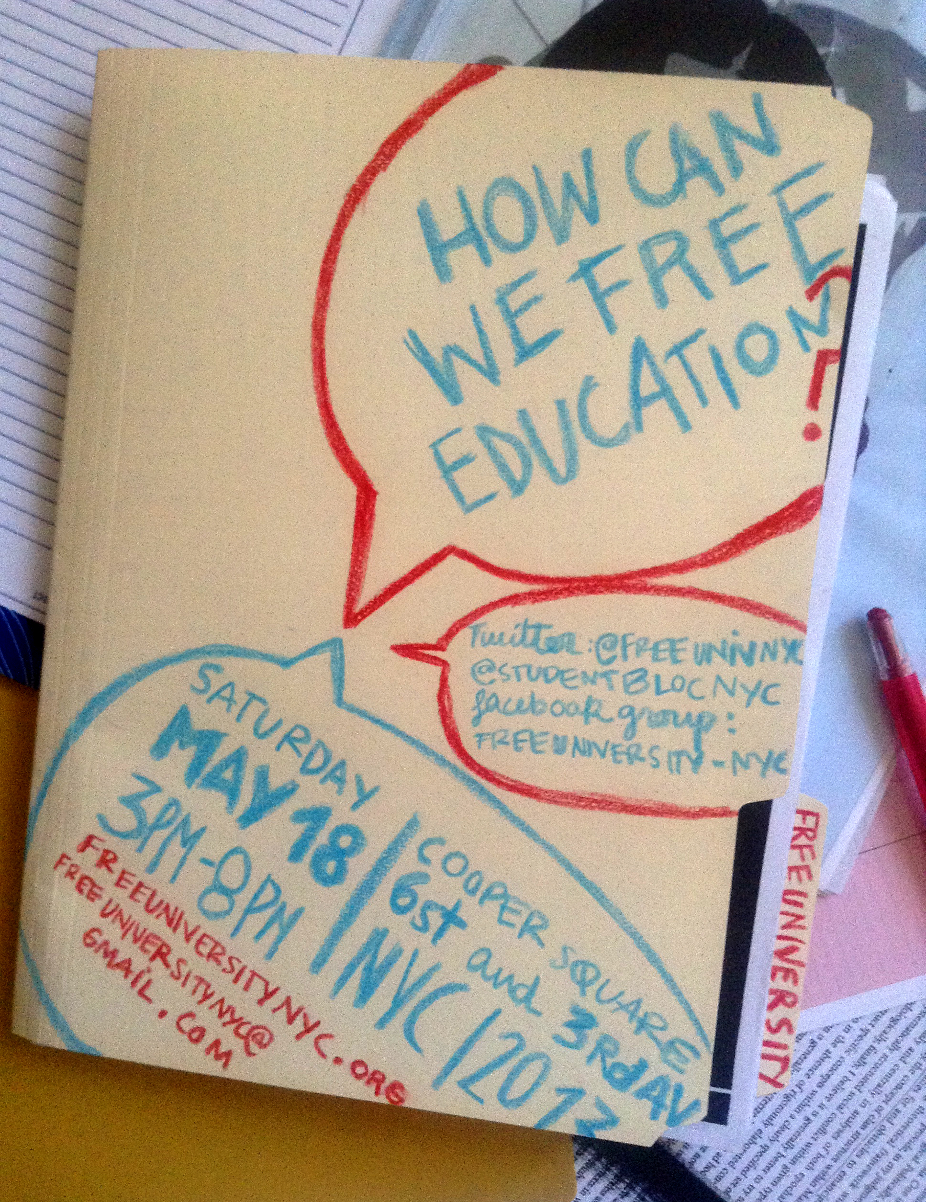
Design by Irene - iosorio.com
*OCCUPIED* COOPER UNION FREE UNIVERSITY
“How can we free education?”
Saturday, May 18, 2013
3pm-9pm

Statement of Intention on Entering the Free University

We enter the space of the Free University with a commitment to:

- Mutual respect and support
- Anti-oppression
- Nonviolence with each other
- Direct democracy

We participants of the Free University:
- support the empowerment of each person to challenge the histories and structures of oppression that marginalize some, and divide us all. These may include ableism, ageism, classism, heterosexism, racism, religious discrimination, sexism, transphobia, xemophobia, among others.
- commit to learning about these different forms of oppression.
- understand individual freedoms are not above our collective safety, well-being, and ability to function cooperatively; individual freedom without responsibility to the community is not the Free University way.
- seek open and compassionate classroom.
- encourage open and non-oppressive dialogues.
- strive for accessible interchanges of languages, knowledge, and discussions.
- understand and respect that there are differences among us.
- expect to listen and be listened to.
- are confident we can learn without policing or being policed.
Deliberate disruptions, accusations, violence, or other violations of this code are not within the spirit nor the hopes of the Free University.

The Free University of NYC Stands in Solidarity

with the Students for a Free Cooper Union

We, The Free University of NYC, openly support the Cooper Union student occupation. We believe that Cooper Union and all education should be free!

We recognize the occupation of the Peter Cooper Suite by The Students for a Free Cooper Union as a vital effort to defend access to a free education for future generations. Their occupation serves as an inspirational, positive, and productive example of resistance in the broader struggle for affordable education in NYC and around the world.

We see clear connections between the struggles students at Cooper Union face and the those of students across New York City. The lines between private and public education in this city have separated us for too long. We will not be divided by institutions, claims to prestige, or profit margins. Public schools are becoming clandestinely privatized, while private schools are increasingly run and financed by our collective student debt. Our grievances are connected and our struggle is necessarily collective.

We know that access to education is our path to empowerment, agency, and success. We continue to fight for the opportunities to affect change in our communities and we believe that accessible education for all New Yorkers is the first step to achieving a more equal and just society.

We stand with the students of Cooper Union as they pressure their administration to recognize and respect the mission of the Cooper Union and hold them accountable to honor the history of their institution and the founding vision of Peter Cooper.

We also see the occupation of university spaces as a legitimate recourse for students to express their discontent over the existing governance structures in their universities. For too long students have been purposefully excluded from decisions that affect their future and the future of their universities. Students and faculty should have more control over their institutions. Students should not be treated as passive consumers of educational commodities; faculty should not feel compelled to act as dutiful enforcers of policy they do not write. Both students and faculty should be recognized as powerful and active members of educational communities, which they build with their own voices. The Cooper Union Student Occupation is a powerful expression of this demand for respect and a demonstration of student power.

The Cooper Union Student Occupation is an inspiration for students across the greater New York City region who are struggling on their respective campuses against austerity measures, against the privatization and corporatization of the University, and against the commodification of learning.

In fierce solidarity,
The Free University of NYC

*OCCUPIED* COOPER UNION FREE UNIVERSITY
“How can we free education?”
Saturday, May 18, 2013
3pm-9pm

All day:
Arts, Crafts, Food, Care station
Bring art materials, blankets, food, and extra care.
Occupy Wall Street Screen Printers station
Bring your own blank paper, shirts, bags, etc. to design.
End-of-semester “work-in” for students and teachers
Get your productivity on together in the park.

Schedule:
Free University-NYC Brief Welcome and Statement of Intention
3pm sharp!

a. “Papier Maché Workshop”
with Cooper Union and CUNY students
3pm

b. “Lessons from the University of California/New School Student Occupations”
New York Year Zero
3pm
Veterans of the 2008-2009 student occupations at the University of California and the New School discuss the recent history of radical student struggle in the U.S.

c. “Why Are We Not Free?”
Cecile Lawrence
3pm
What is freedom? What does it look like, smell like, sound like? Who has it? Who does not? Did we once/ever have it? When? If so, where did it go? How can we retrieve it? Did it get stolen from us? If so, when, how? Or did we give it up? Is this a religious discussion?

d. “Free University-NYC: Ideas Working Session”
4pm
Come help us build the next year of Free U-NYC activism and solidarity. Some topics that will be approached: summer events/ideas; visions for the year ahead; website development; links with other organizers/organizations; lessons from May 1, 3013.

e. “Writing and Free Education from Home, School, and Everyday Life”
Susan Naomi Bernstein
4pm
For new and experienced writers: This course presents the processes of writing for anyone who struggles to write. Together we will develop our own practices of writing for audiences and purposes that connect to our visions of free education, and social transformation for home, school, and everyday life.

f. “Desiring School: Formulations and Performances”
Elizabeth Adams
5pm
What would a school be like that you would want to go to? How can you best describe it, and how can you best perform that description?
Hone your wildest imaginings into startling and pithy formulations. Generate a variety of performances of them in everyday life. Design social heuristics to improve their effectiveness.
Formats: Talking, writing, acting, responding.
Ideology: the “teacher” brings the starting questions and structure because she does not yet have the answers.

g. “Lessons from the Quebec Movement”
Stefan Christoff
5pm
Stefan Christoff will present about the struggle in Quebec and give some background/ context to the demand for abolishing tuition. Stefan is a Montreal-based writer, community activist and musician who recently published “Le fond de l’air est rouge,” a booklet of texts on the Quebec student uprising in 2012.

h. “Facilitation Skills-Share”
Marisa Holmes
5pm
Facilitation is the act of guiding a group through its own process. I will cover intermediate and advanced facilitation techniques, so that we can collectively improve our practice of direct democracy.

i. “The Attack On All Levels On Public Education, Teachers & Teachers Union and the Inadequacy of the National Union Response”
Jackie DiSalvo
5pm
Under the deceptive name of “Reform,” the 1%, supported by both parties, are attempting to privatize education – in elementary and high schools, and colleges. At the same time they are demonizing teachers and trying to destroy teachers and faculty unions, the last stronghold of the union movement. There is also an attempt to control curriculum through high stakes testing in the public schools and the CUNY administration’s take-over of curriculum from faculty governance. This control debases the public school curriculum in a way that alienates students, and ends the academic freedom which is essential to a free society.

j. “A discussion on the social consequences of debt”
Aaron Jaffe
6pm
I’d like to share in a discussion regarding the longer term consequences for indebtedness. How are educational, labor, political, and social responsibilities experienced when burdened with debt? I hope the conversation will be a balance of both personal and political concerns.

k. “Education in Transition: A Discussion on Creating Alternative Learning Opportunities for Regions and Peoples that are In Flux”
Jennifer Lauren
6pm

l. “NYC Universities at a Tipping Point”
with members of All in the Red, Free University, Student Bloc NYC
6:30pm
Cooper Union students occupy their president’s office for over a week, creating a public dialogue on defending free education through nonviolent direct action. Faculty votes of no confidence in administrators spread across Cooper, NYU, and New School. CUNY shuffles in/out Chancellors and Trustee members amidst tuition increases, adjuncts exploitation, a Pathways stalemate, David Petraeus’ announced teaching appointment, and the successful ouster of Medgar Evers’ president. This tipping point in NYC universities can produce new coalitions between students, faculty, and staff workers to make change in our near future. In this discussion, we’ll map out some of these issues and resources, identify key pressure points, and brainstorm strategies for the summer and next academic year.

Short Films by Cooper Union students – Outdoor Screening @8pm
Red Light Ceremony with the Cooper Union student occupation @9pm

NEXT STEPS: Sunday, May 19, 1pm outside Cooper Union: NYC education summer strategy session

