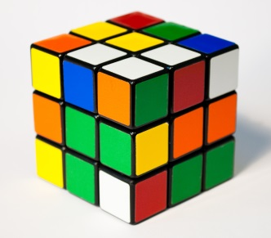
Rubik’s Cube Workshop
Notes: 1st Layer

Notes: 2nd Layer

Steps for last layer  R = right side  U = upper layer  F = front side  L = left side (when looking at it, clockwise rotation is normal)  D = bottom layer  Ex: R‘ is counterclockwise | Goal | Pattern | Remember
1 | To get cross | F U R U’ R’ F’
2 | Flip the cross around till the 4 pieces match the other layers | R U R’ U R U² R’
3 | Rotating the corner pieces | U R U’ L’ U R’ U’ L | The bottom right piece does not move, the other 3 corners rotate clockwise
4 | Flip the corners around | R’ D’ R D Repeat! | Rotate U’ so that the jacked up colors are in the bottom right hand side.

