An example of another irrational number = ________
Things I know about Things I wonder about
irrational numbers…

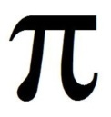
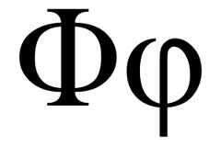
$$\sqrt[12]{2}$$
Let’s Talk Irrational
Task: Fill in the blanks below describing the Real Number System.
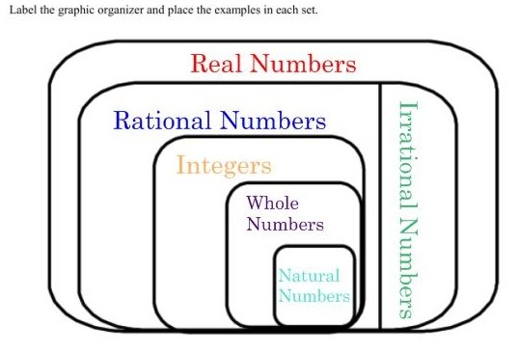

What do you notice? Why do you think this is happening?

An example of an irrational number ______________

