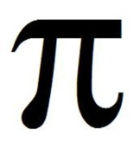
_____LT: I can express deep conceptual understanding of mathematical concepts through writing.
Let’s activate your prior knowledge! Fill in the blanks below. Pi is _____________________________________________
_________________________________________________
= _________ ≠ ________ because ≈ _______
What do you think about the line above? AND Where does pi exist? ______________________________________________________________
______________________________________________________________
______________________________________________________________
______________________________________________________________
______________________________________________________________
Things I know about pi… Things I wonder about pi…

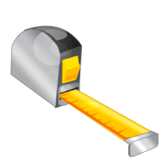
Investigating Pi
Object | Circumference | Diameter | Ratio | Ratio Reduced
All measurements in centimeters
What do you notice? Why do you think this is happening?

