_________LT: I can calculate the mathematics used to build my mobile (graphing method). Teacher name: Abby Shana
MY Mobile
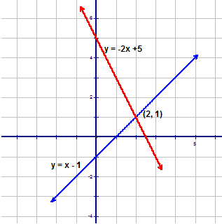
Your name________________________________________________________

Group member #1____________________________ Group member #2_______________________

__________________
__________________
INPUT  Distance  X | RULE/FUNCTION  $$F×D$$ | OUTPUT  Moment  Y
0
1
2
3
4
5
6
7
8
9
10

____g

______g
M₂ = ________________
M₁ = ___________________
_____g
INPUT  Distance  X | RULE/FUNCTION  $$F×D$$ | OUTPUT  Moment  Y
0
1
2
3
4
5
6
7
8
9
10

